Kyphosis dataset

80% traning data 20% test data

[1] " Accuracy of the pruned tree is:"
> print(accuracy)
[1] 0.75

90% traning data 10% test data
[1] " Accuracy of the pruned tree is:"
> print(accuracy)
[1] 0.75

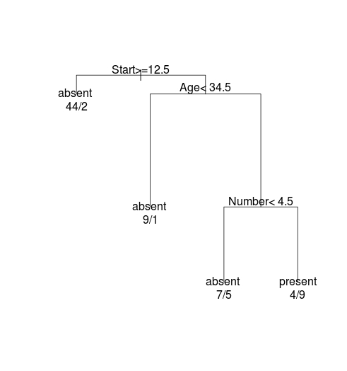
KYPHOSIS ORIGINAL TREE

KYPHOSIS PRUNED TREE

